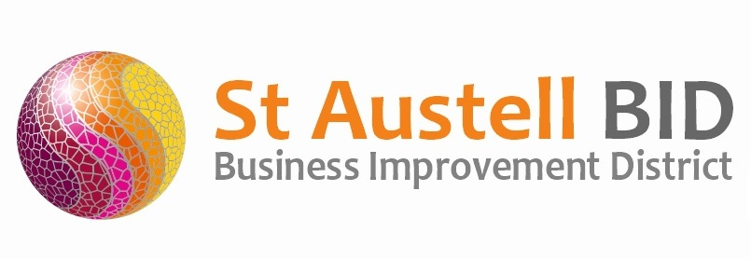
St Austell BID Board Meeting
Minutes of the meeting held on 5th October 2021.

Present: Dale Lovatt (DL), Martin Davies (MD), Bill Holland (BH), Roberto Cubbedu (RC), Martin Davis (MD), Piers Thompson (PT), Cllr Tom French (TF), Neil Woodward (NW), Gillian Mullany & Sean Mitchell (SM).

Apologies: Allan Clare (AC), & Seam Marshal
In attendance: Annette Miller (AM).

- Welcome & Apologies: DL Welcomed everyone to the meeting.

- Minutes of Previous Meeting: The minutes of the board meeting held on the 5th October 2021 were reviewed and approved.

- Finance: Monthly update provided by SM.
  - Income received during the month - £5,827 from the Town Council towards Christmas lights and planting of the red pots.
  - Expenditure this month included the following costs: Administration, Christmas, Bunting and Town support including Wardens & Publicity.

- St Austell Revitalisation Partnership: DL was unable to attend this month’s meeting but forwarded a request that Studio 4 FS should form part of the discussions.TF mentioned that the Town Council would be forming a interview panel for the Project Manager.

- BID Managers Roundup:
We achieved gold in the Southwest in Bloom presentations along with a community award and best BID in the South West.
Safer St Austell was cancelled due to the weather and will be rescheduled.
The CHAOS Tour Bus came in on the 28th October for 2 hours.
We have been granted £25,000 from the Welcome Back Fund.
Banners are now up on the outskirts of town advertising switch-on. These will change on
the 20th to Christmas shopping and family entertainment.
Security continues to patrol and are dealing with more welfare/safeguarding issues. These issues can then be dealt with before they escalate into an ASB

- Christmas: All the entertainment has been booked. Posters and Banners are all in position and will be changed over on the evening of the 20th November. There will be a full stage with sound and lights for all the events. Radio campaign for Christmas will start on the 15^{th of} November. Advertising feature space has been booked in the Voice and 6,000 leaflets will be distributed. Banner and a half page advertisement has also been booked with details of what is happening. We will also promote Christmas events through paid boosts on the Town Facebook page.

- Meetings/AOB: GM Asked if BID could provide presents for Santa. AM explained that this should have been self-finance with money received from previous years donations. It was agreed that £100 would be granted to kick start it again.
PT informed the board that the Seven Stars would become a training centre for people having educational difficulties. MD hoped that work would be starting on Tengo again soon. BH attended the Safer St. Austell meeting with AM. They were very complementary regarding our security team with the help and compassion they have to the public

Meeting closed 18.30
Next meeting 4th January 2022 at 17.30
Burton House

