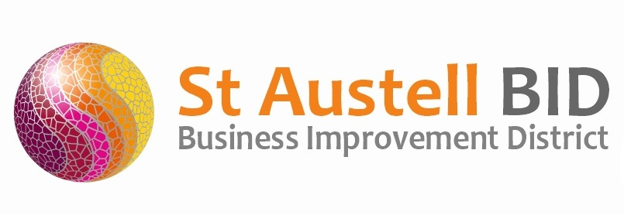
St Austell BID Board Meeting
Minutes of the meeting held on 5th October 2021.

Present: Dale Lovatt (DL), Martin Davies (MD), Bill Holland (BH), Sean Marshall (SM), Roberto Cubbedu (RC), Martin Davis (MD), Piers Thompson (PT) & Cllr Tom French (TF)

Apologies: Allan Clare (AC), Neil Woodward (NW) & Sean Mitchell (SM).
In attendance: Annette Miller (AM).

- Welcome & Apologies: DL Welcomed everyone to the meeting along with our newest board member Piers Thompson from St Austell Brewery.

- Minutes of Previous Meeting: The minutes of the board meeting held on the 7th September 2021 were reviewed and approved.

- Finance: Monthly update provided by AM..
  - Income received during the month - £5,500 Levy payments and £10,000 towards Wardens from the Town Council. Our levy collection rate currently stands at 84%
  - Expenditure this month included the following costs: Administration, Hire of Christmas Lights and Town support including Wardens & Publicity.

- St Austell Revitalisation Partnership: Please see St Austell Revitalisation Partnership Minutes dated September 2021. DL presented the key points from the last SARP meeting and a general discussion ensued. BID board members were reminded to pass on to DL anything they would like to put forward to the next SARP meeting.

- BID Managers Roundup:
Poles and posts throughout the town to be repainted.
Presentation for South West In Bloom is this Thursday in Western Super Mare.
Safer St Austell will be in Alymer Square on the 20th October between 10 & 2.
The CHAOS Tour plans to take place on Thursday 28th October 2021
There will be face painting, creature feature engagement, live music entertainment.

- Christmas: Nearly all the entertainment has been booked this includes free activities for kids like face painting, balloon modelling and a ride. Entertainment will be between 12 & 7 on switch-on and 12 & 6 the following 4 Saturdays. Posters and Banners are being printed. We are hoping to have a full stage for all the events. Radio campaign for Christmas will start on the 15^{th of} November. Advertising feature space has been booked in the Voice and 6,000 leaflets will be distributed. We will also promote Christmas events through paid boosts on the Town Facebook page.

- Meetings: No Feedback

- A.O.B. AM, We are still waiting to hear from Cornwall Council regarding the ‘Welcome Back Fund’ that BID has applied for, hopefully we will hear some news very soon. TF, made a request to consider the Market House for Christmas music to help draw footfall. AM, suggested this was possible but it was previously withdrawn at the request of the Market House tenants.TF, to liaise with Market House Directors and feed-back. DL, reiterated that the monthly BID meetings are a formality and that Directors can by all means email/call at any time throughout the month, in order that BID can be dynamic in implementing its work within the Town.

Meeting closed 18.30
Next meeting 2nd November 2021 at 17.30
Burton House

