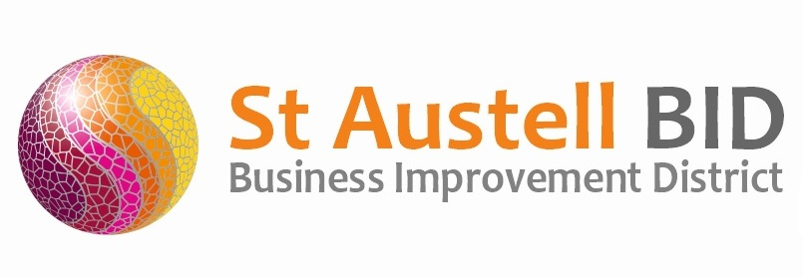
St Austell BID Board Meeting
Minutes of the meeting held on 3rd August 2021.

Present via Zoom: Dale Lovatt (DL), Martin Davies (MD), Neil Woodward (NW), Bill Holland (BH), Grant Macdonald & Cllr Tom French (TC)

Apologies: Sean Marshall (SM), Allan Clare (AC), Roberto Cubbedu (RC), Sean Mitchel (SM) & Allan Clare (AC).
In attendance: Annette Miller (AM).

- Welcome: DL welcomed the board to the meeting.

- Minutes of previous meeting: The minutes of the board meeting held on the 6^{th of} July 2021 were reviewed and approved.

- Finance: Monthly update provided by AM.
  - Income received during the month - £45,000 Levy payments.
  - Expenditure this month included the following costs: administration, Events including Whitegold, Saturday music spots & Cornwall Pride, Printing, town support including wardens & publicity.

- St Austell Revitalisation Partnership:

- BID Managers Roundup: No news about the Welcome Back Fund but are going ahead with implementation of our proposals. It was felt that delaying this would cause the town further damage.
Busking points are now in place.
Deep clean completed.
Saturday entertainment has commenced. This Saturday (07/07/21) we have the Restormal Concert Band.
Free dance lesson on Mondays during the school holidays in Alymer Square.
Seating in Biddick’s Court has been repainted.
Information officers/wardens are continuing to patrol.
Judging for Southwest in Bloom went very well judges were impressed with what we manage to achieve with the funds we have.
Safer St Austell were in Alymer Square on the 23rd of July with many of our partners. The public find the chance to engage rewarding.

- COVID 19: Replaced authoritative signage with softer more welcoming initiative. Still keeping signage in place regarding wearing of masks in customer facing businesses.

- Meetings: BH & AM attended the Safer St Austell monthly meeting. Discussions took place regarding formulating a plan with designated persons being responsible for projects and timelines with ASB at the top of the list. BH & AM also request that there should be more regular engagement with the public by the Safer St Austell Partnership. This should take the form of all agencies engaging monthly with the public in Alymer Square.

- A.O.B.

Meeting closed 18.15
Next meeting 7th September 2021 at 17.30
(This will be the AGM)
White Hart Hotel

