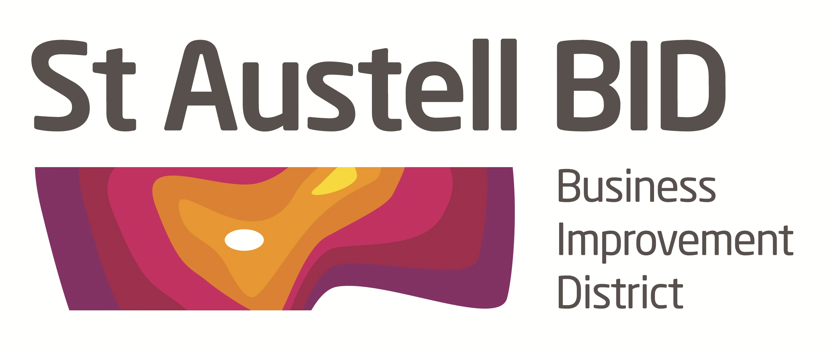

St Austell BID Board Meeting
Minutes of the meeting held on 2nd October 2018.

Present: Richard Hurst, Brian Palmer, Martin Davies, Ameena Williams, Aaron Niles, David Halton, Giles Bingley & Hayley Newton
Apologies: Dale Lovett, Roberto Cubbedu, Kelly Fegan & David Hendry

In Attendance: Annette Miller, Jon Teague & Ffion Stanton

- Welcome: RH opened the meeting and welcomed Jon & Ffion.
- Minutes of previous meeting. The minutes of the board meeting held on the ^{4th} September were reviewed and approved.
- Community Led Local Development. Using finance set up by the European Social Fund to support people and businesses in targeted areas. Small Grants (£1,000 – £10,000) for community organisations and businesses to develop economic activities, growth and job creation. Skills development, education, training, coaching and mentoring for individuals. Funding available till 2022. Larger grants are available. www.communityledcornwall.co.uk
- Finance. Donations were made this month to the Library and St. Austell Friends of £100 each. A loan of £700 made to St. Austell Friends so they can go ahead a print cards & calendars. £2,400 received from the PCC for body cams and jackets to be used by BID & White River security teams. £6,000 still to be called off from the Council.
- Website. The chance to purchase staustelltown.co.uk has arisen, HN to negotiate cost. The site is getting about 50 clicks a day but not a good advertisement for the town. Better to hold the domain name ourselves rather than give outdated information. Must be fully transferred to BID. Board agreed to proceed subject tp outcome of negotiations.
- Parking. DH & AN met with the Town Council. Free parking for Christmas late nights was agreed. DH submitted a proposal to the Town Council from the Chamber and this will be assessed at the next full council meeting. AN to continue as BID representative for any future meetings.

- Christmas. Plans going well MD to forward requests for stalls to AM to peruse. Stak to take a stall for the first & last night. Possible swing boats and other stalls.

- BID Managers Report.

Security. The board agreed to re instate security for half term 22, 24 & 26 October. Try Maz & Cornwall Hospice Care are trialling shopwatch radios. Shoplifting training was not very well attended.

Plastic Free. BID supported the Mayor’s plastic free launch that took place in WRP. Weather was appalling for this launch but it was well received.

Whitegold. The town’s third Whitegold festival was well attended and good feedback has been received. Some stall holders returning for Christmas late nights.

- AOB.

SABEF. Awarded £1.1m from Coastal Communities fund, great news for St. Austell.

Growth Fest. Attended by RH & AM Positive for new business in St. Austell.

SWIB. Awards on the 4th October in Yeovil and the nationals on the 19th in Belfast.

Meeting ended at 7.20

Date of Next Meeting: Tuesday 6th November at 5-30pm

At the White Hart Hotel.

