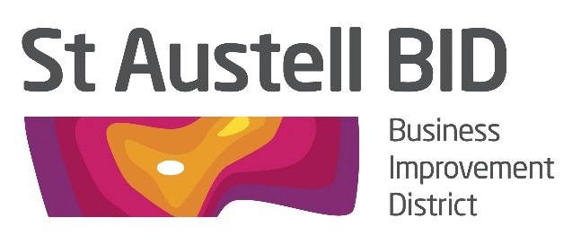

BOARD MEETING

Tuesday 6th November 2018, 5.30pm
The White Hart Hotel, St Austell

AGENDA

- Welcome and Apologies RH

- Minutes of Previous Meeting RH
(2nd October 2018)

- Financial Update GB

- Christmas Update AM

- BID Managers roundup AM

- In Bloom Feedback RH/AM

- SABEF Update RH

- AOB

