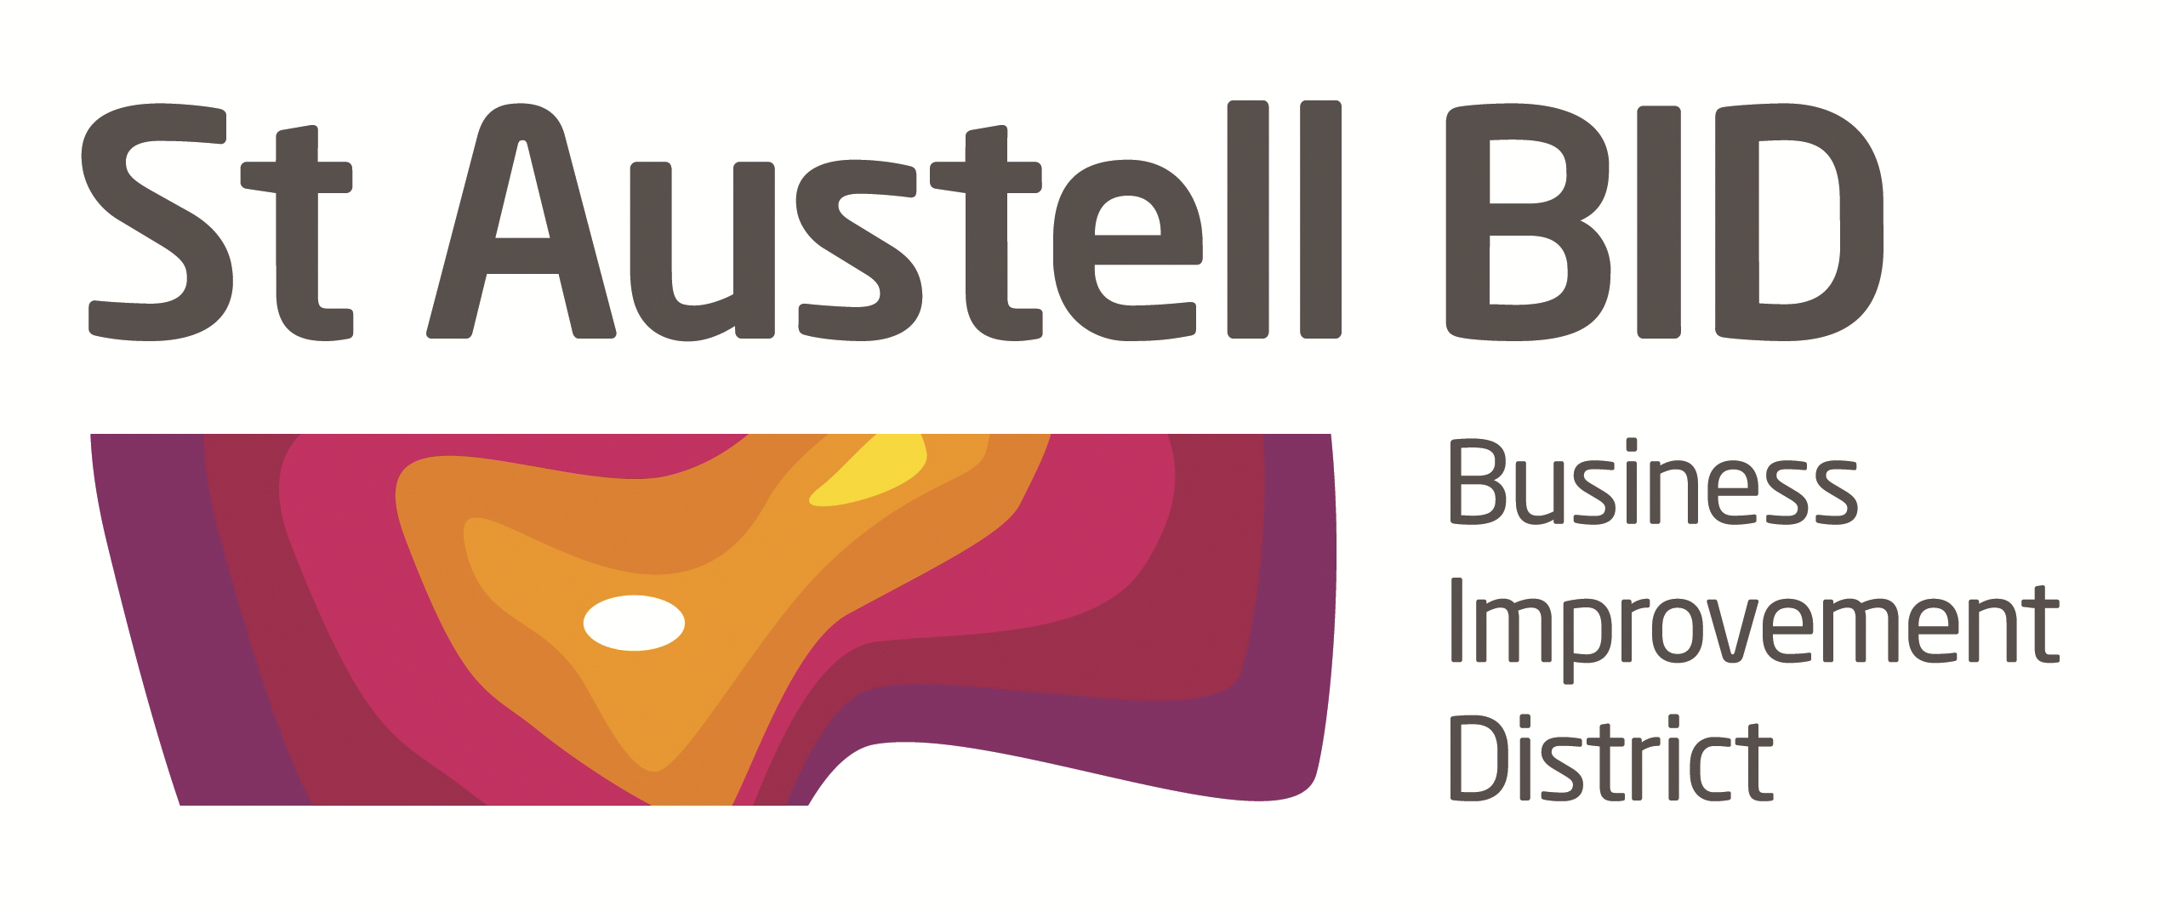

St Austell BID Board Meeting
Minutes of the meeting held on 4th September 2018.

Present: Roberto Cubbedu, Richard Hurst, Brian Palmer, Dale Lovatt, Martin Davies, Aaron Niles, David Halton & David Hendry.
Apologies: Jenny Yelling, Giles Bingley, Ameena Williams Kelly Fegan & Hayley Newton

In Attendance: Martin Searle & Annette Miller.

- Welcome: RH Opened the meeting and welcomed David Hendry from the Market House to the board.
- Minutes of previous meeting. The minutes of the board meeting held on the 7th August were reviewed and approved.
- THL initiative. Martin Searle Townscape heritage scheme project officer explained there is a pot of £1.3 million over a 4 year period aiming to restore buildings and shop fronts. Starting with 14 high priority properties, contact has been made with owners/leaseholders of these. This project is sponsored by Cornwall Council, St. Austell Town Council, BID and the Heritage Lottery Fund. It is hoped that Holy Trinity fountain will form part of this project. Martin will report back to the board with a quarterly report. Funding is also being applied for to help update the Discovery Map website and make it interactive.
- Biddick’s Court. Waiting for Cormac to replace the granite so the pots can be positioned. We are looking for businesses to sponsor the planting. Wetherspoons, Sew & Fabric & Photography by Marina have offered £100 a year towards this. Mock up of welcome sign add Biddick’s Court and make bigger. White River donated the pots and will donate some benches after the New Year. St. Austell Bay Chamber will own the pots and benches.
- Working Groups. What groups should be established? Security, Christmas, Premises, PR & Digital. The board was asked to think about this and bring back ideas to the next meeting. KF to be the lead on PR for BID.

- BID Financial Report. The accounts for 5 months ending 4th September 2018 were circulated. £40,000 was paid into the account this month. Expenditure was minimal.

- BID Managers Report.

Security/wardens. The board agreed to fund till the end of September and start again in the middle of November till the New Year. Crime Prevention Training course will be on the 18th September at the Fire Station 9.30. PCC funding of £2,400 has been granted towards body cams and jackets. Smith’s are trialling a shopwatch radio.

Telephone Boxes. Condition reported to BT Open Reach an we are monitoring to see what action they take

Library. Board agreed to make a £100 donation to the Tommy statue.

Banners Trinity St. A licence will have to be applied for every year, done for the coming year.

Purple Pound Day. 13th November an inclusive experience for customers who have physical and hidden disabilities to be publicised nationally. White River has been running their sensory days for a couple of years now and we will work with them. https://purpletuesday.org.uk/

Autism Hour. 6th – 13th October sign up your business. https://www.autism.org.uk/get-involved/tmi/autism-hour.aspx

Plastic Free. Working with the Mayor to promote this initiative. Attending the launch with information for businesses. Event to take place 26th September

Whitegold. Collecting offers from businesses.

Website. Email addresses removed and send button inserted for Chair & Vice Chair.

Church Street. Will be closed for gas works 17th Sept – 8th Oct, for some of this.

- AOB. JY from Boots resigned from the board due to family commitments, she continues to support the BID and we thank her for the valued contribution she has made.

Meeting ended at 7.55

Date of Next Meeting: Tuesday 2nd October at 5-30pm

At the White Hart Hotel.

