ANNUAL GENERAL MEETING
Tuesday 9th June 2015
The White Hart Hotel, St Austell
Chairman’s Report for Year Ending
31 March 2015

The St Austell BID continues to work on the two key themes on which it was voted in:

Theme A – Attractive, Accessible and Safe
We have developed planting schemes across the Town Centre gaining recognition from South West in Bloom of a Silver award. This will be improved dramatically in 2015 by way of both quality and quantity. Security in the town continues to be a concern and we have been working behind the scenes with a number of agencies on this vitally important subject. In conjunction with the Town Council we are revitalising the CCTV network in St Austell Town Centre and also rolling out a “Shop Watch” radio scheme to enable better communication and management of this difficult issue. We have engaged with the local Police who support this initiative wholeheartedly and will also help its roll out in the coming weeks.

Theme B – Events, Marketing and Cost Savings
We have focused events on fewer but bigger events and particular seasonal timings supporting events around Christmas, Feast Week and Torchlight Carnival are key. We have produced a new version of the St Austell Town Guide which has been distributed across the area to ***how many** holiday parks, visitor attractions etc. This has also been digitalised into the “St Austell Town App” another vital part of promoting the businesses and services throughout and within the town on a modern digital platform also enabling engagement of a wider audience.

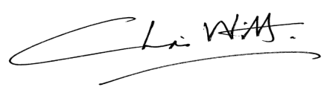

Chris Witt
Chairman
St Austell BID
May 2014

