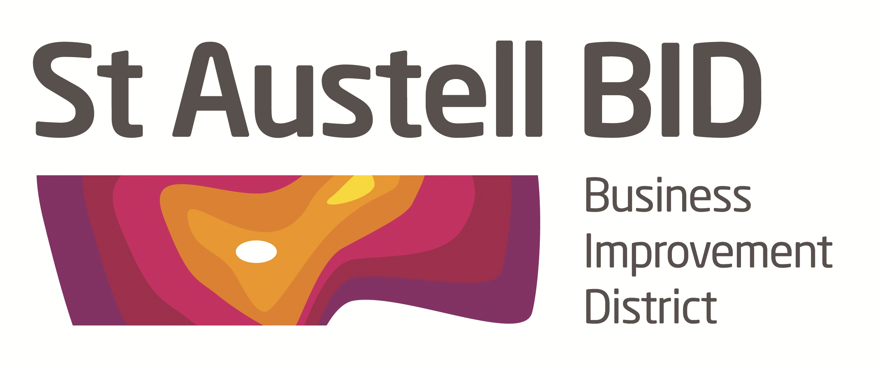

St Austell BID Board Meeting
Minutes of the meeting held on 6th June 2017.

Present: Roberto Cubbedu, John Kneller, Ameena Williams, Richard Hurst, Brian Palmer, Hayley Newton, Giles Bingley, Noel Krishnan, Dale Lovatt, Jenny Yelling and Aaron Niles.

In Attendance: Annette Miller.

1. Welcome: JK welcomed the Board to this short Board meeting directly following the AGM particularly to discuss and agree actions around Agenda item 2. Welcome to new Board members: Jenny Yelling from Boots & Aaron from Wetherspoons.

Apologies: Richard Pears and Ameena Williams

2. Security and ASB.
It was recognised that the Police presence has not yet been established and ASB/Begging was on the increase. It was agreed to resume BID funded security patrols for 2 random days per week. Annette will schedule according to PCSO rota.

3. BID 2.
The Levy Payer consultation document is finished and will be sent out next week, everybody would need to chase up local levy payers, it is important that we receive a good response.

Date of Next Meeting : Tuesday 4th July at 5-30pm

At the White Hart Hotel.

